Standard PPE Requirements For Department

Steel toe cap footwear is required for the department operation, whether these be in the form of boots or shoes, both are acceptable. Please contact your departmental manager immediately if you do not have the correct footwear. | 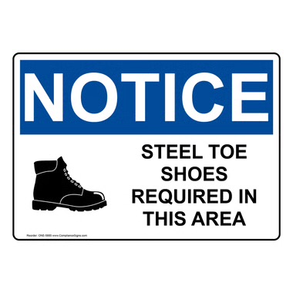
Ear protection is provided at the entrance to the department and is a requirement during production activity times. Please contact your departmental manager immediately if you require alternative hearing protection. | 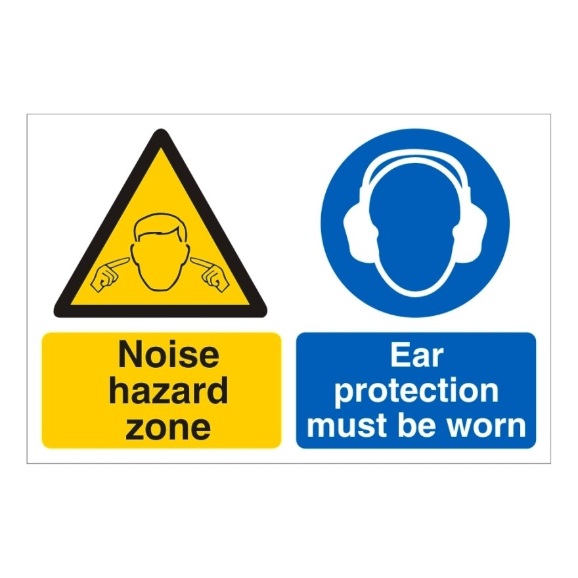
High Visibility jackets must be worn whilst operating the trucks at all times. These are provided within the department. | 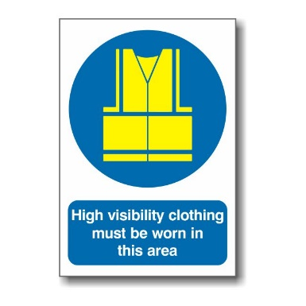

General Safety

Operators and trainees must be aware of how close the truck is behind them at all times as feet can be very close to the front whilst travelling | 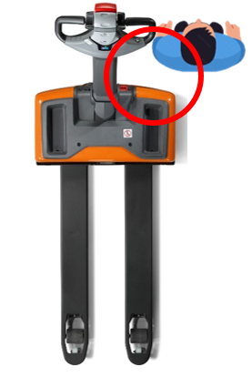
Any damaged caused whilst using the electric powered truck must be reported immediately to the direct manager of the department or the relevant manager of the department in which the damage occurred | 
Understand how to safely isolate the truck in the event of an emergency and how the E-Stop works | 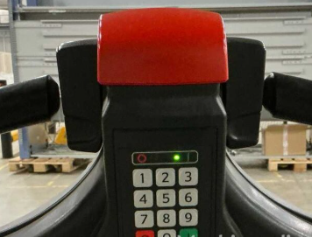
Explain and understand the pre-shift checks required before using the electric truck, go through the steps and highlight any faults found to the department manager

Basic Daily Operations

Explain and demonstrate how the truck moves forwards and backwards using the tiller controls | 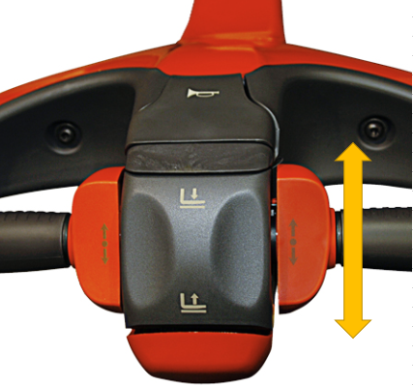
Explain and demonstrate how to lift and lower loads using the controls, use a small load as an example | 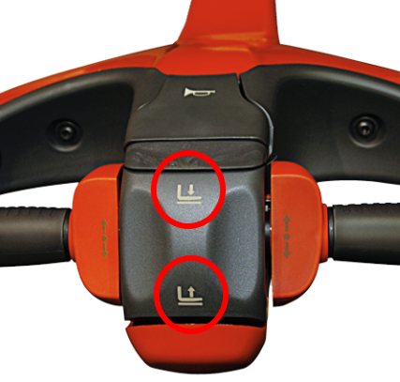
Demonstrate and train the trainee on how to move loads safely, explain where to stand whilst moving loads and how not to navigate movements when operating
Allow the trainee to demonstrate confidence and understanding of how to operate safely before using full loads. Only when you are happy that the trainee is to standard can they be signed off this procedure

How to, and How not to operate Electric Trucks

How to? | How NOT to?
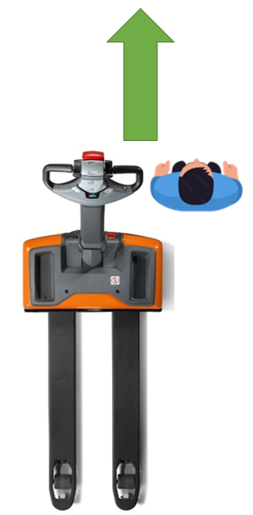 Always drive the truck facing forwards and standing to the side | 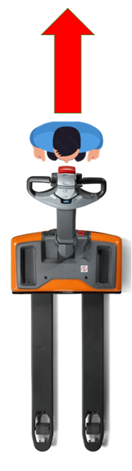 Never drive the truck backwards with your back to the surroundings
Always drive the truck facing forwards and standing to the side | 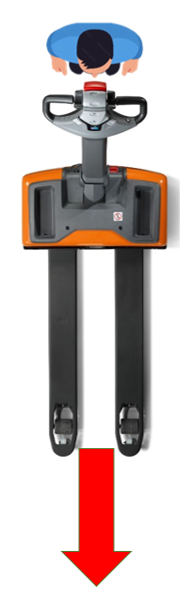 Never drive the truck with the forks forward, unless when loading

